**2010-11 First Semester**

**B. Tech. Project**

End-Semester Report

**FLUIDIC CONTROL OF COMPRESSOR SURGE**

S Sajin

Y7373

Under the guidance of

**Dr. Abhijit Kushari**

Department of Aerospace Engineering

Indian Institute of Technology Kanpur

**Abstract**

Surge and rotating stall are phenomena, which can be regarded as mature forms of the natural oscillatory modes of the compression system. An initial disturbance starts with a very small amplitude and high frequency but grows quickly into a large amplitude form with low frequency. Thus, the stability of the compressor is determined by the stability of these small amplitude waves that exist prior to stall or surge.

This project aims at identifying these small amplitude waves which act as precursors to stall and surge. Once identified, the compressor shall be driven into surge. The compressor surge shall then be controlled by using an active fluidic feedback control, which will damp the hydrodynamic disturbances.

**Experimental Setup**

The experimental setup consists of the following parts:

* 10 HP Crompton Greaves 3Phase Induction Motor (max. frequency 50 Hz) connected to a two stage axial compressor
* Variable speed drive for regulating rpm (Altivar 312, Schneider Electric)
* A venturi-tube for measuring mass flow rate
* A butterfly valve for regulating mass flow rate
* Sensors
  + KISTLER Basic Line Torque Sensor
    - Power Supply 18-26 V DC
    - Range 0 to 10 V; Torque: 0 to 50 Nm
  + AUTO TRAN Pressure Sensor; Model 851-48-P-18-S-P
    - Power Supply 18-24 V DC
    - Range 1 to 5 V; Pressure: 0 to 4 psi
  + Kulite Ultra Miniature Pressure Transducer, XCS-062 series
    - Supply Voltage 10 V DC
    - Range 0 to 50 mV; Pressure 0 to 5 psi gage
  + ASCX Differential Pressure Sensor
    - Supply Voltage 5 V DC
    - Range 0.25 to 4.75 V; Pressure 0 to 1 psi
  + SM5812 Differential Pressure Sensor
    - Supply Voltage 12 V DC
    - Range 0.5 to 4.5 V; Pressure -0.3 to +0.3 psi
* SCIENTIFIC Multiple power supply PSD3304 (30 V max)
* Data Acquisition Card – National Instruments USB-6210
* Weights for torque calibration
* A Computer Workstation for recording and observing data

**Theoretical Formulation**

Pressure Ratio

The Pressure Ratio of a compressor is defined as the ratio of outlet pressure to the inlet pressure of the compressor.

Hence, Pressure ratio, Prc =

Mass flow rate

The mass flow rate through the compressor is done using the venturi. A schematic of the venturi is as under

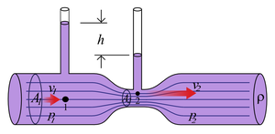

Fig. 1 – Schematic diagram of a venturi

The determination of mass flow rate through the compressor makes use of the assumption, that the flow is not only subsonic but incompressible as well. This is allowed as the maximum blade tip velocities are of the order of 50 m/s (corresponding to M < 0.2 for ambient conditions) and the compressor sucks in air from the ambient, which is practically at rest (i.e. Inlet velocity, U ≈ 0 m/s)

The expression for the mass flow rates is determined from the continuity and momentum equations as follows

Given a volume flow rate, Q, we have, the continuity (dropping the density term as it is constant for incompressible flow) and momentum (Bernoulli equation) equations as under

 \begin{cases}
 Q = v_1A_1 = v_2A_2\\
 p_1 - p_2 = \frac{\rho}{2}(v_2^2 - v_1^2)
 \end{cases}


Simplifying we have,

 Q =
A_1\sqrt{\frac{2\left(p_1 - p_2\right)}{\rho\left(\left(\frac{A_1}{A_2}\right)^2-1\right)}} =
A_2\sqrt{\frac{2\left(p_1 - p_2\right)}{\rho\left(1-\left(\frac{A_2}{A_1}\right)^2\right)}}


Assuming circular cross-section, the area ratio in the above formulae can be replaced by the square of the ratio of diameters.

For the venturi used

D1 = 14 inches

D2 = 8.5 inches

Density of air, ρ = 1.2 kg/m3

Hence, Q = 0.0508432 $\sqrt{∆P}$\* , where ∆P is the pressure drop across the venturi

So, Mass flow rate, m = ρ\*Q = 0.061012 $\sqrt{∆P}$

\*

**Work Done – Stage 1**

A Virtual Instrumentation on LABIEW was used to record data. The data (voltage reading) was recorded at the rate of 1024 samples per second for a period of 5 seconds. Hence over 6000 values of voltage were recorded for each reading.

The torque sensor was calibrated by providing torque using slotted weights. The calibration plot of voltage of torque v/s voltage was obtained as given in Fig. 1.

Fig. 2 – Torque Calibration Plot

Next, the variation of pressure with rpm was obtained for fully open (maximum mass flow rate) and fully closed (zero mass flow rate) configurations at six different ports, viz.

1. Compressor Inlet
2. After 1st stage
3. Before 2nd stage
4. After 2nd stage
5. Mouth of the venturi
6. Throat of the venturi

The pressure variations of ports 1-4 are found to be as follows (Atmospheric Pressure = 735 mm Hg = 98027 Pa)

Fig. 3 – Pressure variation across compressor (fully open configuration)

Fig. 4 – Pressure variation across compressor (fully closed configuration)

**Inferences**

* The range of pressure variation across the compressor is determined for different mass flow rates as well as rpms. This shall be used to determine an appropriate pressure sensor for each port.
* The pressure ratio for the fully open configuration is found to fall after an rpm of 2100. This is due to flow separation on the blades of the compressor, resulting in pressure loss. Hence, as of now, we can assume the design rpm of the compressor to be around 2100 rpm.
* The decrease in pressure with increase in rpm is attributed to the increase in mass flow rate (and hence increase in velocity) due to increase in rpm. This is verified by the mass flow rate plot obtained by measuring the pressure difference across the venturi (Fig. 5). The almost zero mass flow rates for the fully closed configurations are as expected.

Fig. 5 – Mass flow ratev/s rpm at different configurations

**Work Done – Stage 2**

The above work was done to get a rough idea of the ranges of pressures observed at the various ports. AUTO TRAN being a versatile sensor was able to work over a wide range of pressures. However, since only one sensor was available, it was pretty cumbersome to take readings for all the ports using the single sensor.

The experimental set up was then revamped by having separate sensors for each of the ports. The following was the configuration of the sensors across the ports:

**Kulite Sensors**: Gage pressures at ports 1 and 4

**SM5412**: Pressure rise across the compressor (1 – 4)

**ASCX Pressure Sensor**: Pressure difference across venturi (5 – 6) to determine mass flow rate

The schematic of the new experimental set-up is as follows

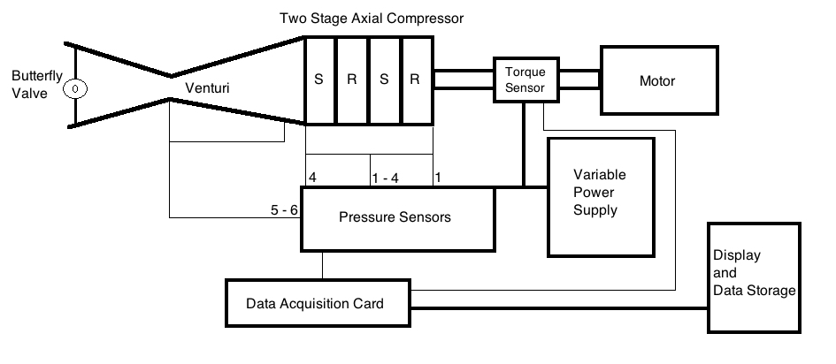

Fig. 6 – Schematic of Experimental Setup

Using this setup the compressor was run at a particular rpm at different mass flow rates. The compressor pressure ratio at different mass flow rates is determined. This is called the compressor characteristic for the particular rpm. Hence compressor characteristics were obtained for the compressor at different rpms.

Fig. 7 – Compressor Characteristics and different rpm

Using the data points obtained, a plot of $\frac{∆Vθ}{U}$ v/s $\frac{Vz}{U}$ was obtained as under. The calculations for $\frac{∆Vθ}{U}$ and $\frac{Vz}{U}$ make use of the same assumptions as for calculating Q

Fig 8 – ∆Vθ/U v/s Vz/U

The data was also checked for noise and other frequency components. A Fast Fourier Transform of the gage pressure data from ports 1 and 4 was obtained using SigViewer.

The FFTs of the data are as follows

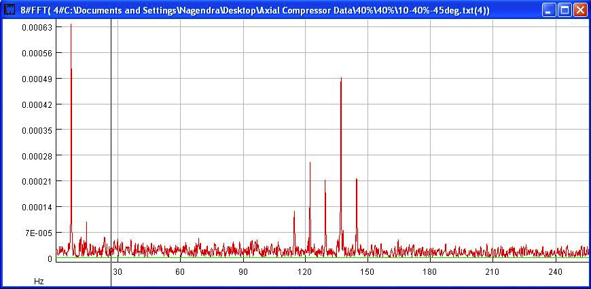

Fig. 9 – FFT of the data for Port 1 (Compressor Inlet)

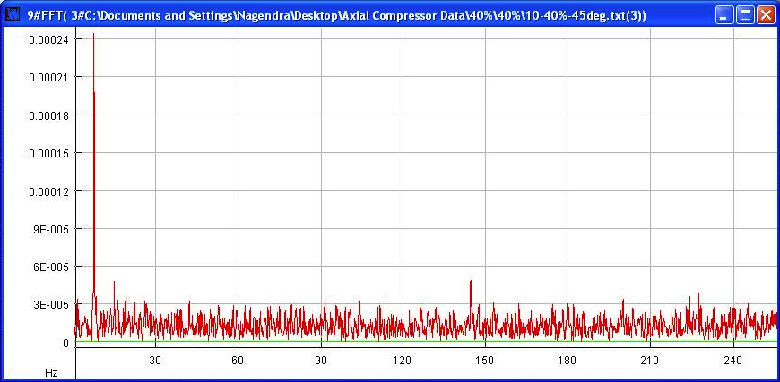

Fig. 10 – FFT of the data for Port 4 (Compressor Exit)

**Inferences**

* Compressor Characteristics are obtained at different rpms. The Pressure Ratio is found to increase with mass flow rate for a particular rpm. After a particular value of mass flow rate, however, the pressure ratio starts falling. This is in accordance with the theoretical predictions.

The only drawback in the plot is that the downward sloping region is very narrow. To make the region more pronounced, we shall need air to enter the compressor at higher velocities. However the compressor at present is sucking in air from the ambient, which is at rest. To suck in air at higher velocities, we will need to modify the experimental setup.

* Within experimental limits, the plot of $\frac{∆Vθ}{U}$ v/s $\frac{Vz}{U}$ obtained was found to be in agreement with the theoretical predictions.

Theoretically, we have,

= 1 – \* (tan α1+ tan β2)

where, α1 is the absolute flow angle at inlet (constant for a particular flow), and β2 is the relative flow angle which, at the design point is equal to the blade angle.

If the compressor behaves ideally (similar to design point) at all flow conditions, the angles are constant and the equation translates into a straight line. However due to non-design behaviour, the curve deviates from the straight line as shown.

Fig. 11 – ∆Vθ/U v/s Vz/U - Theoretical Predictions

The experimental plot is in accordance with the theoretical prediction at off design conditions.

* Dominant frequency in the range of less that 1 Hz is indicative of a systematic DC component as error in the data. Similarly a dominant frequency around 50 Hz or multiples of 50 would be due to the noise encountered due to the supply lines.

As is clear from Figs. 9 and 10 frequencies below 1 Hz and in multiples of 50 Hz do not have a dominant component. Hence errors due to a DC component or noise due to the supply lines are negligible

**Conclusion**

The Compressor Characteristics have been obtained for different rpms. They are in confirmation with theoretical predictions.

Proceeding along the direction of decreasing mass flow rate along the obtained characteristic will result in the pressure oscillations resulting in surge. This shall be the next stage of the experiment. Once surge is induced, we shall control it using an appropriate fluidic control.

**Future Plan of Action**

December: Obtain precursors to compressor-surge

Induce the compressor to go into surge

Next semester: Control surge by using an appropriate fluidic feedback